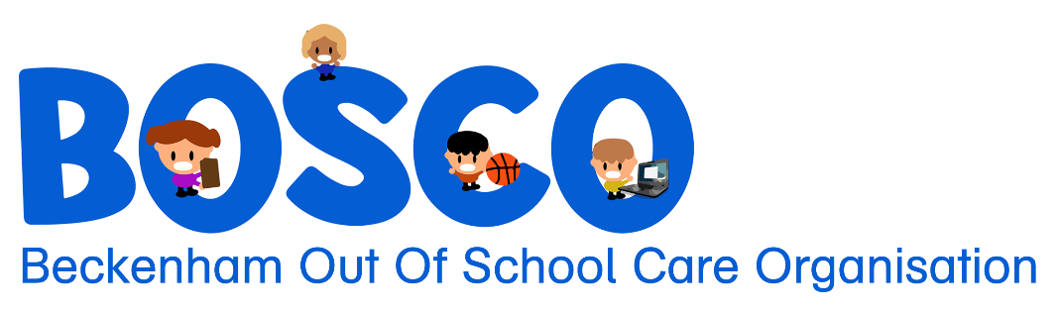
71 Sandwich Rd, Beckenham
Christchurch, 8023
027 645 6632
office@bosco.org.nz
www.bosco.org.nz
Charitable Status: CC40574

Terms and Conditions

Enrolment, Fees and Payments:

- Placement in the Before School, After School or Holiday Programmes is at the discretion of BOSCO.

- All enrolments must be made using BOSCO’s booking system, Aimy Plus. Parents/Guardians are responsible for ensuring all information and contact details, including authorised pickup information, is up to date in Aimy Plus, at all times.

- Definition Regular booking – A recurring booking with a constant pattern and days of attendance

- Definition Casual booking – One off or irregular booking often made on short notice

- Late bookings, including walk-ins, cannot be guaranteed, and will only be accepted if space is available.

- Fees are as advertised, however are subject to change. BOSCO will provide at least one months’ notice of any fee changes.

- Invoices will be emailed weekly. It is your responsibility to ensure Accounts are being received from BOSCO.

- Failure to pay fees by the due date on the Invoice, or as arranged with the Programme Leader, may result in all bookings being cancelled.

- Accounts over thirty (30) days will be forwarded to Baycorp (NZ) Ltd for recovery of fees and an administration fee may be added to your account. No further bookings will be accepted until arrears have been paid or a payment plan has been discussed.

- Holiday programme – Five (5) working days’ notice is required to cancel or change any bookings.

- Before and After School programme regular bookings - Five (5) working days’ notice is required to cancel or change bookings permanently (i.e withdrawing your child from Bosco or a change in scheduled regular bookings). Full fees will be charged for the whole of the notice period regardless of attendance.

- Before and After School programme casual bookings – Bookings need to be made and confirmed at least one (1) working day in advance, bookings will not be approved over a weekend.

- Where children attend Bosco without an accepted and confirmed booking - Parents or caregivers may be contacted to collect their child if staff ratio’s do not allow for the child to be present on site.

- Before school, After school and Holiday programme - Full fees are charged for any absences (e.g., sickness, holidays) from any of our programmes. This includes extended periods of absence while the child is still enrolled at BOSCO. An additional $5.00 fee will be added to your Account if BOSCO has to contact you repeatedly or several times a week to find out where your child is.

- As part of a recurring booking, full fees are payable on Public Holidays that fall during school term time.

- Fifty (50%) of fees (up to a maximum of 3 days for holiday programmes) will be charged for the duration of a closure if Management must close for any reason e.g, earthquakes, snow, pandemic related illness. The Management Committee will reconsider this where a larger scale event has taken place.

- A late fee will be applied to your Account if tamariki are collected after 6pm for After School or Holiday Programme (or 3pm if booked in for short day during holidays). Late fee will be $1.00 per minute. This fee will also be applied if dropped off before 7.30am for Before School or Holiday Programme (or 8.30am for short day).

Health and Safety:

- Parents/Guardians are responsible for ensuring Medical Information is up to date in Aimy Plus, at all times and advise the Programme Leader of any changes.

- The Programme Leader or Supervisor may seek urgent medical care if it is considered necessary (including ambulance if required).

- Sunscreen is available and will be applied during Summer months, please ensure your child has a sunhat with them.

- Tamariki requiring medication during any programme must have a medication form filled out prior. These are available from the Programme Leader or Supervisor.

- BOSCO complies with Health and Safety Policies and National Oscar Standards. All staff are screened, trained, and are gaining appropriate experience for the job they do. BOSCO will not be held responsible for genuine accidents.

- BOSCO has a zero tolerance to bullying, physical violence, inappropriate language, and disruption to Programmes. After consultation with Parents/Guardians, repeated failure to follow reasonable direction or a single significantly unacceptable behaviour event may result in tamariki not being able to attend the Programme, on a temporary or permanent basis. This is at the discretion of the Programme Leader and the Management Committee.

General:

- Tamariki are only deemed to be in the care of BOSCO from the time they arrive at the BOSCO room until their departure when they exit the premises.

- Tamariki are required to be signed in by a Parents/Guardians unless otherwise agreed with the Programme Leader) for the Before School and Holiday Programmes and by a staff member for the After School Programme. Tamariki must be signed out by someone identified on profile unless prior arrangement with Programme Leader or Supervisor has been received. Staff will sign tamariki out for the Before School programme.

- Tamariki will only be allowed to depart BOSCO in the manner/with persons identified on the Aimy Plus booking system. Tamariki will not be released into the care of someone unidentified and the parent or guardian will be contacted.

- Parents/Guardians must contact the BOSCO Programme Leader during programme hours to allow a child to leave. We will not be able to let a child leave if we have not spoken to parent/guardian first. The Programme Leader and Supervisor and office have phones that are always answered during programme hours.

- Although proper care is exercised at all times, BOSCO cannot accept responsibility for misadventure, injury, damage or loss sustained to person or property while at any of our programmes and other places visited for activities.

- Tamariki are responsible for their own property.

- Tamariki may bus for any excursion off site. Tamariki may also go on walks (with staff) within the Beckenham and surrounding local area.

- Tamariki may participate in all advertised activities and any other replacement activities that may be required.

- All comments/complaints/queries of any nature are to be addressed to the Programme Leader or Supervisor in the first instance or Chairperson if appropriate.

- Tamariki may be using devices i.e chromebooks at any of the BOSCO programmes. They will not be allowed on Youtube, games with age restrictions or games depicting violence. There will regular conversations with Tamariki about cybersafety.

- Mobile phones are not allowed to be used during tamariki’s time at Bosco, phones have to remain in the child’s bag.

- Every effort has been made to provide accurate information in programme brochures, however, sometimes changes occur due to circumstances beyond the control of BOSCO Staff and Management Committee who are unable to take liability for these situations.

- All programmes of BOSCO are operated independently of Beckenham Te Kura o Pūroto. The Teachers, Board of Trustees and Principal of Beckenham Te Kura o Pūroto have no responsibility of BOSCO nor any of its activities.

- BOSCO Staff and or the Management Committee will liaise with any outside agency including, but not limited to - Oranga Tamariki, the Principal, Deputy Principal and/or tamariki teachers where necessary for the care of children.

- A copy of our policies and procedures are available on our website or from the Programme Leader, all these policies must be acted upon.

